bh
JOY FOR CHILDREN UGANDA FOURTH QUATERLY REPORT FOR CHILDREN WITH DISABILITIES PROJECT

2017
NAKAIBALE LYNDA EUNICE
JFCU
12/20/2017

Executive Summary
The Children with disabilities project, in the fourth quarter of 2017 registered tremendous achievements. All the activities were accomplished in the three months of October, November and December. In this quarter, various approaches have been used in the implementation of activities in the slum areas of Bukoto, Mulago, Bwaise, Makerere Kivuulu and the surrounding areas like Kawempe and Nabweru. The approaches ranged from the community based i.e. praying with the children and their caretakers and neighbourhood sensitization meetings. A friendly approach was used while interacting with parents/ caretakers and the CWDs amongst other approaches.
Introduction
Children with disabilities project is implemented under the Kampala Slum Women Development project. Many activities were carried out in this quarter and they included the following; neighbourhood sensitization meetings, home visits, community outreach and issuing Christmas gifts.
These activities were implemented in the areas of Bukoto, Mulago, Makerere Kivuulu, Bwaise and other surrounding areas like Kawempe, Kyebando and Nabweru.
The fourth quarter of 2017 has been great. Activities have been conducted and implemented in the different slums. Children with disabilities range from ages of 1 to 18 years of age. The activities favour both the young and old children.
In this fourth quarter, the project officer met about 40 to 51 children in the slums. So many activities have been carried out this month with the intentions of;
Objectives
To develop the children’s potential i.e. their potential to play, to read, learn etc.
To boost the children with disabilities confidence and self-esteem.
To provide counselling and guidance for parents of children with disabilities.
Activities carried out in the fourth quarter of 2017 were not limited to; home visits, community outreach, parents meeting, networking and neighbourhood sensitization as discussed in detail bellow.
- Home visits
The home visits were widely carried out in the four slums where the project is implemented. The main reason for visiting these homes is for the project officer to get a deeper understanding of the families and the children on the project, to create a strong authentic relationship between the parents/ caretakers and the organisation. These home visits are mainly carried out in the families of the CWDs. So many activities are carried out during these home visits and they include the following;
Counselling; involved interaction between the care takers and the project officer. Counselling is a helping and a problem-solving process whereby the care takers shared their problems with the officer where the officer intervenes by guiding them. This process also helps one get a deeper understanding of the persons problem, situation, and devises means to solve the problem better.
Counselling has been greatly used during the home visits where the project officer counselled care takers of children with disabilities. These parents were also given words of encouragement and advised to make informed decisions about themselves and the lives of their children.
Counselling also helped care takers still struggling with raising their children to cope. Continued talks with the care takers have helped change their mentality towards life and has helped them develop a sense of belonging and hope for better.
Praying;
Praying means having ample time in the presence of God. During the weekly interventions in the homes of children with disabilities, praying was done which involved converging together and saying a prayer. The members present during the visit and the officer converge and pray together. During this quarter through prayer, the care takers were encouraged and comforted. They also got to learn of God’s love for all of us.
Many care takers now call upon the name of the lord through prayer when faced with challenges or situations that they consider difficult to them, and God comes to their rescue for example
“We didn’t have food at home and I didn’t have money to buy food for the child. However, I prayed and surprisingly, a friend of mine paid me a visit and brought me some rice, beans and powdered milk which saved the day.” Said ms Naluwu Teddy. She believed and called upon the Lord and he provided through her friend.
Exercises
Exercises were done on children that were in need of these exercises. Exercises were done on the children’s parts like the legs, hands, feet, with home of helping reduce pain, improving easy blood circulation in the body and improving mobility.
The project officer carried out some basic exercises on 30 children during the visits this quarter.
Children were also supported to hold items, sit and stand according to their different abilities which has produced positive results.
Play
Play is every child’s right. By the virtue of fact that children with disabilities are children as well, it’s only proper to engage them in play and games that are appropriate and accommodating to them which promotes their right to play.
Children with disabilities use sensory toys like the caterpillar, spiky balls, tambourines, stacking pots, bottle of glitters to mention but a few. These toys are carried by the officer on a daily basis and given to the children during the home visits.
Engaging children in play has helped improve their levels of socialisation and interaction, build their mental abilities and has kept them active.
Basic teaching;
Basic teaching involved equipping children with skills in reading, learning the alphabet and first words using flash cards. Telling time, shading writing words using. All these activities aim at improving the children’s ability to memorize, learn and practice what they have been taught.
To the few children in school in school like Cathy, such activities sharpen their brains even more and help them learn better the things taught them at school which improves their performance.
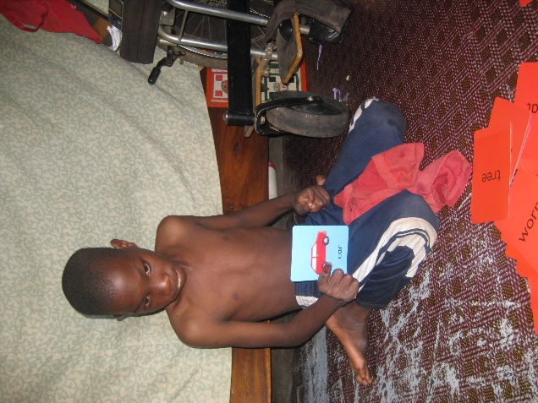
Kato Jonathan learning words using flash cards during the home visits.
Community outreach
In the bid to bring services closer to the care takers and children with disabilities, Joy for Children carried out a community outreach on Saturday 18th November 2017.
The community outreach was carried out at SHARP Primary school in Kyebando slum where the children accessed various services like physiotherapy, occupational therapy, medical check-ups, cervical cancer vaccination for the girls
The community people as well as the care takers accessed various services from HIV/AIDs testing and counselling, deworming tablets among others. The care takers were also preached to with the aim of encouraging them and were also engaged in a business skills training which equipped them with skills on how to start up a business, how to run it and generally how to grow it. Many care takers were pleased with the training and pledged to put into practice the skills they had learnt in their daily businesses.
One of the care takers by the names of Auma Doreen doing exercises on her daughter Camilious during the community outreach.
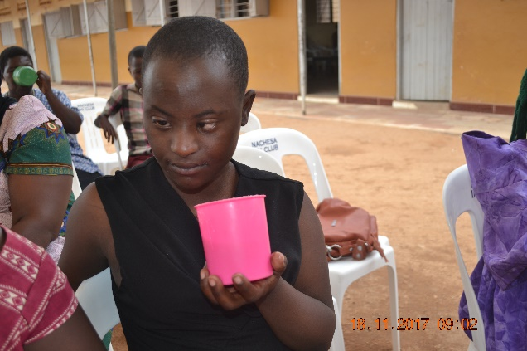
Amelia during the community outreach
Christmas gifts
The Christmas season is about sharing Gods love and this involves sharing with neighbours, family, friends, the needy and so many other people.
The birth of Jesus is significant in the lives of many people. Giving out Christmas gifts like rice, eggs and sugar to the families of the children with disabilities was great. It was a way of expressing Gods love for the families.
The families were happy on receiving the Christmas gifts. It is amazing to watch the children with disabilities happy and their families. These families appreciated the gifts and committed themselves on continuing with the gesture.
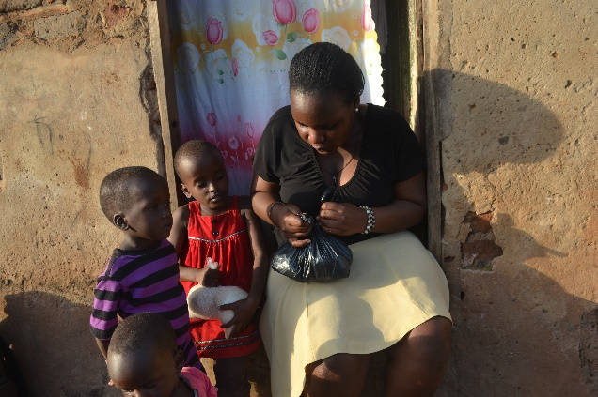
Nabukera Cathy holding her Christmas gifts in her hands.
Neighbourhood sensitization meetings
Neighbourhood sensitization meetings are carried out every quarter in the different slums of Kampala where the project is implemented. These meetings mainly involve the neighbours of a family with a child with disability. The meetings involve about 10 people who gather in the home of a child with a disability and discuss different issues in regard to disability.
Two neighbourhood sensitization meetings were carried out this quarter in the slums of Kyebando and Bwaise. The people in attendance were taught the causes of disability which included using drugs while pregnant, lack of antenatal services, genetics, alcohol and substance consumption, STIs that expose the unborn child to birth defects, poor feeding while pregnant among other issues. The people were also taught measures which they can employ to prevent the occurrence of birth defects and disabilities in children. Some of these included; accessing antenatal care services while pregnant, treating all STIs, avoiding drug use, feeding properly while pregnant etc.
The neighbours were cautioned to love the children and families of children with disabilities. They were further told to stop the stigmatization, discrimination and segregation of children with disabilities and children based on assumptions like the children were bewitched, cursed which are false. The care takers thanked their neighbours for being supportive and cautioned them to continue spreading the word.
If we are to create societies, communities, homes and a country that is inclusive and accepting of children with disabilities and persons with disabilities as a whole, then such neighbourhood sensitization meetings are a great step in realising this dream.
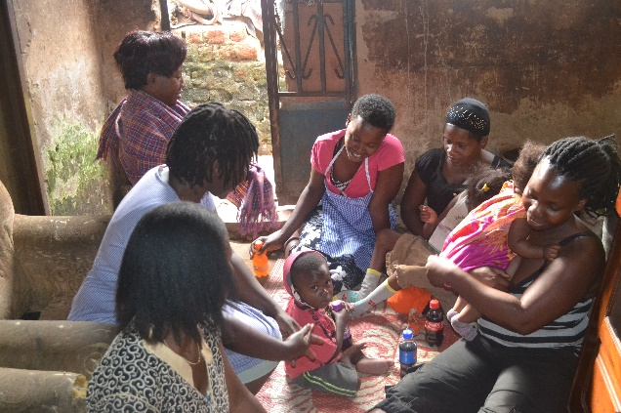
Ms Auma Joyce mother to Gift interacting with her neighbours during the neighbourhood sensitization meeting.
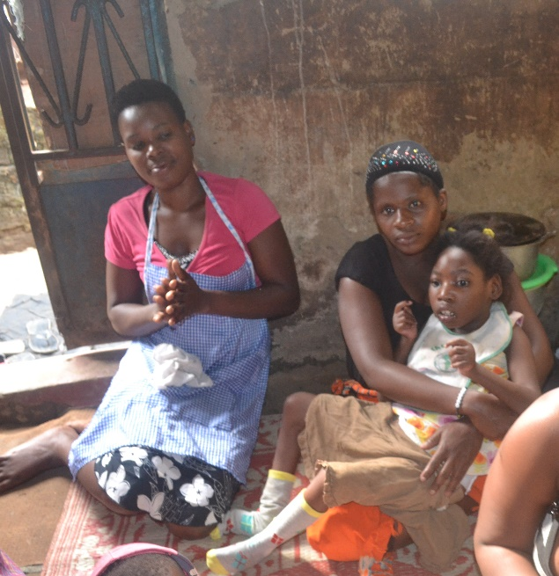
One of the neighbours carrying Namukwaya Gift.
Health insurance
Bugembe Simon and Tumusime Nicholas received treatment from Kitante medical centre using their medical insurance cards. Bugembe Simon suffered from malaria whereas Nicholas had fever and flue. These children were treated in Kitante and recovered.
Care takers appreciate the medical health insurance which has helped many of their children access medical services and saved the lives of their children. Since most care takers don’t have money, these free services are helpful to them.
General achievements for the fourth quarter of 2017
Two children accessed medical services using their medical health cards.
Three children have learned how to pronounce words using the flash cards. (Kato Jonathan, Cathy Nabukeera and Muzire Mike).
About 40 children have been visited out of 55 children on the project. This is a great achievement.
One child by the names of Nabillah Nakyanze was operated on from CoRSU and is recovering at Katalemwa.
About 200 people attended the community outreach with about 24 of these children with disabilities and about 50 care takers.
Ms Naluwu Teddy saved 30, 000 shillings this quarter and anxiously looks forward to saving more in 2018.
Semujju Stephens’s ability to hold items improved. He can now hold items.
There is more involvement of men in the lives of their children with disabilities which is good.
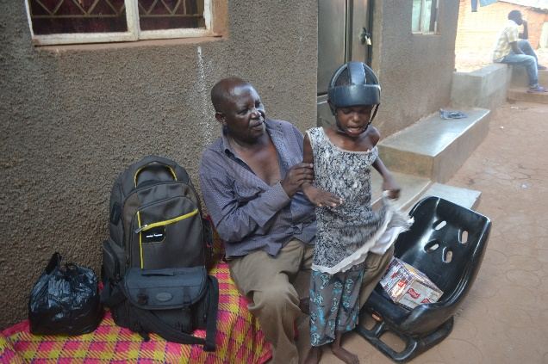
Anita with her uncle during the home visit.
General challenges faced by the project in the fourth quarter of 2017.
Impassable drainage channels especially when it rains in Kyebando, Bukoto and Bwaise slum. It’s difficult to access most homes in a wet environment.
Loss of our project coordinator Ms Kabahubya Phiona and her son which affected project implementation for about two weeks.
Recommendation
In future, if we are to give out Christmas gifts to the families and children with disabilities, we should give them out during a gathering like a parents meeting or community outreach. This will help those parents that are not visited weekly to access their gifts.
Conclusion

The children with disabilities project has restored people’s hope, created awareness about disability in the communities through its various activities like the community outreach and the neighbourhood sensitization meetings which have slowly created a conducive environment for the children with disabilities to grow to their full potential.

.

